Module 4 Challenge: PyCitySchools Analysis

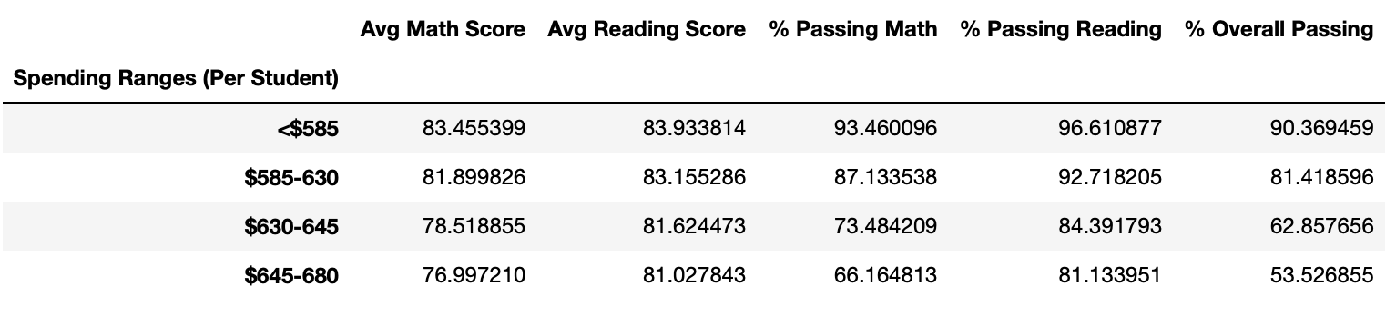In the Challenge we extracted the date from both a school and student perspective and combined the two to run the analysis using pandas. After running the analysis we can confidently conclude that when it came to school funding, a higher funded school, not always meant higher reading and math scores as shown by the table below:

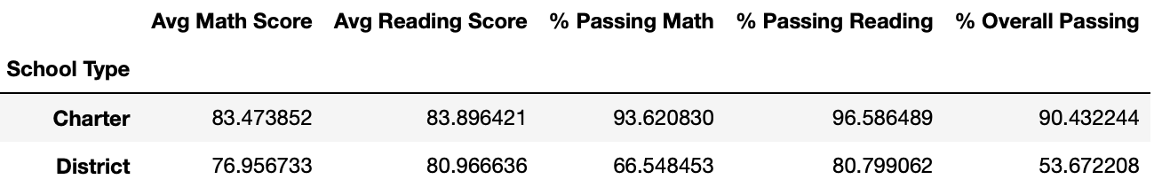Alternatively, we can also conclude that when comparing charter schools and district schools, charter schools had a higher overall passing percentage as seen in the table below:

We can attribute the success of students in charter schools to them having a smaller student count meaning that the probability of the student to teacher ratio is lower allowing a more intimate class setting.

